**PROJECT: E-HOSPITAL MANAGEMENT SYSTEM**

**Name: Sameen Noor**

**Reg No: 2023-BCS-077**

**Section: BCS-III(B)**

**Report**

**Background:**

The E-Hospital Management System is a cutting-edge solution aimed at revolutionizing healthcare management by digitizing and automating hospital operations. Traditional systems heavily rely on manual processes and physical records, which often result in inefficiencies, errors, and potential data loss. The adoption of a digital system addresses these challenges by providing a reliable, secure, and easily accessible platform for managing hospital data. Physical records are susceptible to damage, misplacement, and unauthorized access, while digital systems offer robust security measures and streamlined data retrieval. By implementing an E-Hospital Management System, healthcare institutions can significantly enhance operational efficiency, improve patient care, and ensure compliance with regulatory standards.

**Introduction:**

A comprehensive system to manage hospital operations. Focuses on patient management, appointment scheduling, and billing.

**Purpose:**

* Streamline hospital operations.
* Improve patient care and administrative efficiency.

**Technologies Used:**

* Java for application development.
* Oracle Database for data storage.
* Swing for GUI components.

**Description:**

Developed using Java, the E-Hospital Management System is designed to streamline essential hospital functions such as patient admission and discharge, comprehensive patient record maintenance, and doctor schedule management. This centralized platform enables seamless interaction and data sharing among hospital staff, ensuring that patient information is readily accessible to authorized personnel. The primary objective of this project is to create a reliable, user-friendly environment that supports healthcare providers in delivering high-quality care while optimizing administrative processes. Additionally, the system facilitates efficient appointment management, reducing wait times and maximizing resource utilization, ultimately enhancing overall patient satisfaction and operational effectiveness.

**Problem Statement:**

Traditional hospital management systems face numerous challenges, including data loss, inefficiency in handling patient records, and difficulties in departmental coordination. Physical records are at risk of being damaged by environmental factors such as fire, insects, and natural disasters. Manual handling of records increases the likelihood of errors and misplacement, which can adversely affect patient care and hospital operations. Furthermore, the lack of real-time access to patient and doctor information can lead to significant delays in emergencies. Manual scheduling of appointments often results in conflicts and inefficiencies, causing inconvenience for both patients and healthcare providers. These issues underscore the need for a robust, automated system that addresses the limitations of traditional hospital management practices.

**Methodology:**

* Fronted development using Java Swing for the user interface.
* Background integration with Oracle Database to store hospital data.
* Using JDBC for database connectivity and operations.
* Created user-friendly forms for data entry and management.

**Patient management:**

**Features:**

* Add new patients.
* Update existing patient details.
* Retrieve patient information for viewing or editing.

**Key Functionalities:**

* Fetch patient details from the database.
* Update patient information.

**Appointment scheduling:**

**Features:**

* Select a doctor for the appointment.
* Choose the appointment date.
* Provide a reason for the appointment.

**Key Functionalities:**

* Load doctors from the database.
* Fix an appointment with the selected doctor.

**Billing Management:**

**Features:**

* Record billing information for patients.
* Set payment status.
* Include timestamps for check-in and check-out.

**Key Functionalities:**

* Save billing information:
* Records the total amount and payment status for a patient's bill.
* Uses current timestamps for check-in and check-out dates/ times.

**Description:**

1. **Analysis of Existing Processes:** Conduct a thorough analysis of current hospital management processes to identify areas for automation.
2. **System Design:** Develop a system architecture that leverages Java for robust, object-oriented programming.
3. **Module Development:** Create individual modules for patient management, doctor management, and appointment scheduling, ensuring comprehensive coverage of all hospital functions.
4. **Implementation:** Code the system using Java, integrating the different modules into a cohesive platform.
5. **Testing:** Perform rigorous testing to identify and resolve any issues, ensuring the system operates smoothly and efficiently.
6. **User Feedback:** Incorporate feedback from healthcare professionals to refine the system, enhancing its usability and effectiveness.
7. **Deployment:** Roll out the system across the hospital, providing training to staff to ensure seamless adoption and utilization.

**Output:**

**Login Form:**

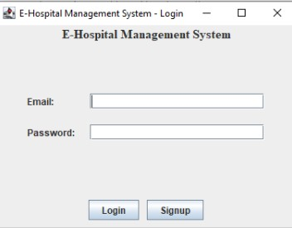

**Signup Form:**

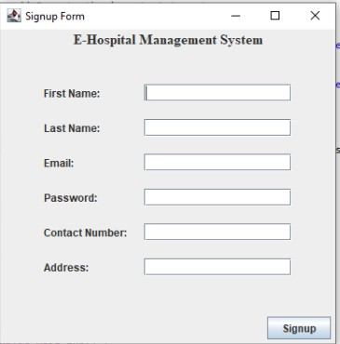

**Update Patient Detail Form:**

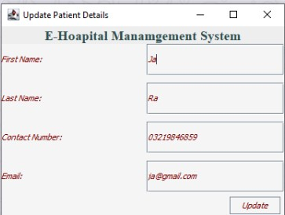

**Doctor Management Form:**

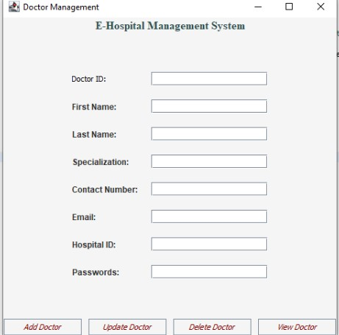

**Manage Billing Form:**

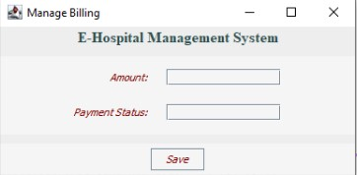

**Patient Dashboard Form:**

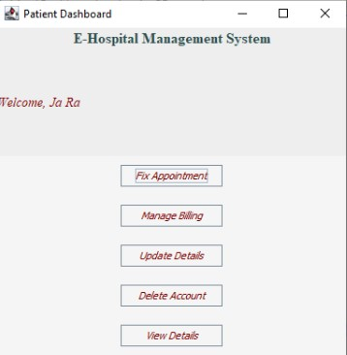

**Fix Appointment Form:**

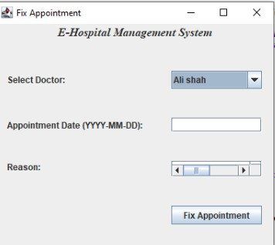

**Advantage:**

The E-Hospital Management System offers numerous advantages, including enhanced efficiency and accuracy in managing hospital operations. By digitizing patient and doctor records, the system reduces the risk of data loss and ensures that information is readily available when needed, leading to improved patient care. Healthcare providers can access complete and accurate information quickly, making informed decisions. The system's scheduling capabilities help prevent appointment conflicts and ensure better utilization of available resources. Additionally, the system's ability to generate detailed reports aids in performance monitoring and decision-making, helping hospitals optimize their resources and improve overall operational efficiency. Improved coordination among hospital staff through seamless data sharing and communication reduces delays and errors, ultimately enhancing the efficiency and effectiveness of hospital management.

**Conclusion:**

The E-Hospital Management System represents a significant advancement in healthcare management, addressing the inefficiencies and risks associated with traditional, manual systems. By automating key functions and providing a centralized platform for managing patient and doctor records, the system enhances the overall efficiency, security, and quality of hospital operations. Developed using Java, the system leverages robust technologies to ensure reliable and efficient performance. The adoption of the E-Hospital Management System not only improves patient care by providing quick access to vital information but also supports healthcare institutions in optimizing their resources and complying with regulatory standards. As healthcare continues to evolve, digital solutions like the E-Hospital Management System will play a crucial role in enhancing the efficiency and effectiveness of hospital management, leading to better patient outcomes and improved operational efficiency.